INTRODUCTION

1. INTRODUCTION

A large number of companies visit for recruitment in campus every year and recruit eligible students from the campus. The whole recruitment process, right from announcement of company schedule to hiring students, the entire process is handled by placement office with help of new placement coordinators. During this process, the college students solely on the placement coordinators, who are prone to irregularities and mistake. The use of traditional technology and methodology for the entire process make the process difficult.
The placement coordination system here is to overcome the traditional manual process of job fair or placement process in colleges and create an easier automated fashion of companies approaching colleges as well as notifying students and allotting them to particular placement programs based on company requirements. This system can be accessed and effectively used throughout the organization with proper login enabled. This system is hence easy to use and helps students get notified on interviews, exams or other placement process they could attend by using our web application at any time. Our application helps companies register at college and set job posting details (set required type of individuals) and students that match this detail provided by company are sent notification to attend that companies’ placement process. By utilizing our system of placement will tremendously increase simplicity of process and can effectively contribute towards inspiring more companies as well as students to participate in these events, Even though the concept of a placement coordination system is quite large and the potential of such a system can cover major functionalities of a placement process, we here only intend to cover a small portion where a filtering mechanism is used to sort out the right students to the companies needed criteria. By this mechanism, for the company: the efforts for filtering out candidates and finding suitable ones for selection process is eradicated and for students: the registration process is much simpler with wide and easy access as well as they get to automatically apply for the right placements events based on their academics and company needs. The placement coordination system is a complete web based system that is to be intended in one college as its primal initial deployment stage, then by some modifications it could be upgraded to a format that every college could use.
.

SYSTEM ANALYSIS

2. SYSTEM ANALYSIS

System analysis is the process of gathering facts, diagnosing problems and using this information to recommend improvements of the system. Thus, an analysis is inevitable part of any system for their better working and satisfied performance.

2.1 Existing System

The existing system does all process manually. As the existing system the whole recruitment process, right from announcement of company schedule to hiring students, the entire process is handled by placement office with help of new placement coordinators. During this process, the college students solely on the placement coordinators, who are prone to irregularities and mistake. The use of traditional technology and methodology for the entire process make the process difficult.

Disadvantages of Existing System

• Requires several paper works
• Difficult for students to choose and manage between placement events they should attend
• Requires more staff or students to be involved in volunteering and managing a placement event
• Companies has to go through unwanted candidates attending event
• Less companies have knowledge of a placement event happening in a college
2.2 Proposed System
The aim of the proposed system is to develop a system with improved facilities. The problem of the existing system will be overcome by the proposed system such as information’s are maintained in the database, it gives more security to data, reduces paper work and save time, Decrease workload on Placement Coordinator. System Can attract more candidates(students) to attend the program from in or out of campus due to ease of registering and notification feature. it conducts placement event all year long

providing more opportunities for students. Filters right candidates required for company as well as providing only notifications on events the student is capable of attending. More companies will participate without much advertising cost.

Advantages of Proposed system
• Can access from anywhere
• Provide security of information
• It is fully automated
• Avoiding fake registration
• Save time and cost
2.3 Module
Placement coordination system mainly contain 3 modules

• Admin-placement coordinator
• login
• View registered companies and verify
• Send notification to student and company

• Company
• Registration
• Login
• View status
• Add vaccancies
• View filtered students
• View notifications
• Edit profile

• Student
- Registration
- View notification
- Edit details

2.4 Sprint
Sprint 1
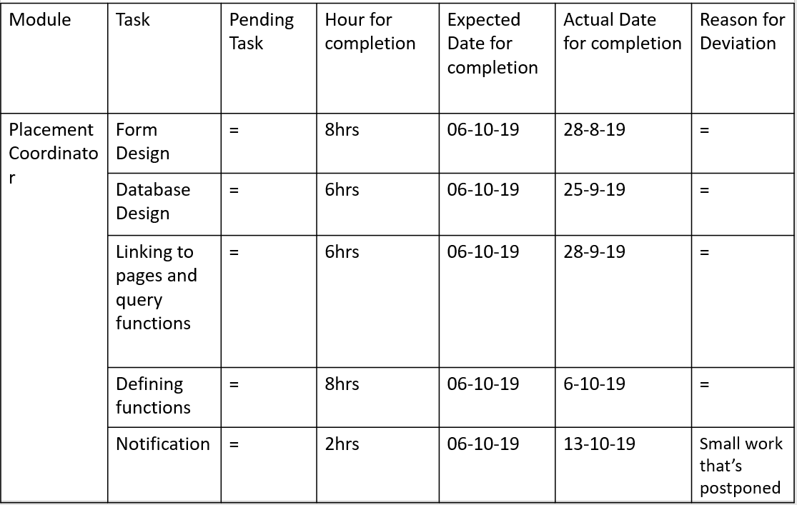

Sprint 2
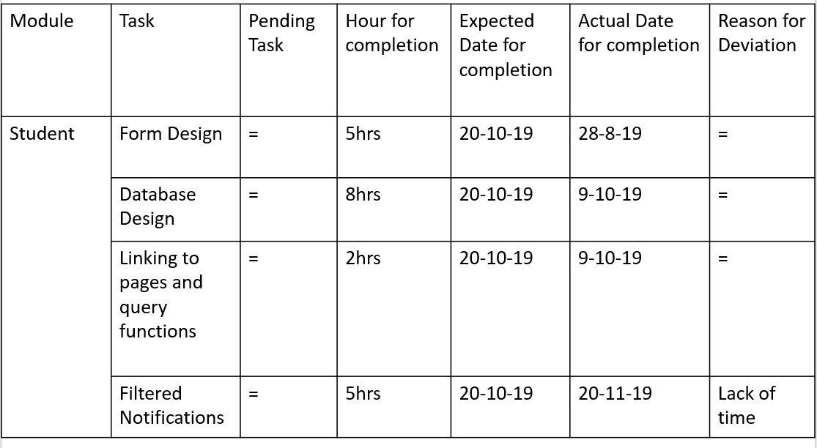

Sprint 3
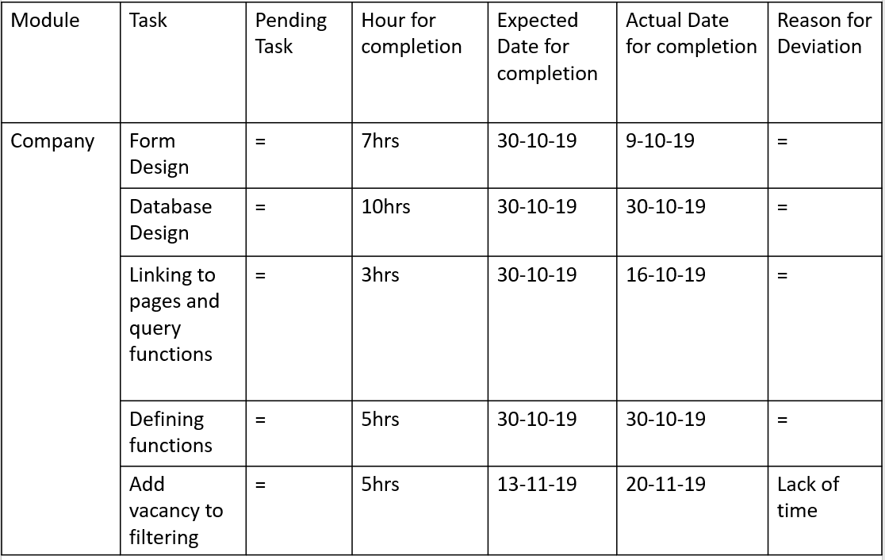

2.5 User Stories

The organization needs a system that makes the process of placement connecting between multiple parties such as students and various companies to be easier. The placement coordinator who is the head in charge of the entire process involving in the program needs to login to our web based application to approve or disapprove companies that register through manual verification, one other core functionality is to send notifications to students and companies. Others who register on our system are the students and companies, the company while waiting to be approved or disapproved the students can directly enter their home screen to view notifications of company placements they can attend on a particular date. meanwhile the companies after approval can add their required criteria’s for the type of students they need here they also specify they job category. this data is used to match students who are eligible to attend the event and are send notification in an automated fashion.

FEASIBILITY STUDY

3. FEASIBILITY STUDY

An analysis of the ability to complete a project successfully, taking into account legal, economic, technological, scheduling, and other factors is considered as feasibility study. Rather than just diving into a project and hoping for the best, feasibility study allows project managers to investigate the possible negative and positive outcomes of a project before investigate the possible outcomes of a project before investing too much time and money.
3.1 Economic Feasibility
The economic analysis is done to determine the benefits and savings that are expected from candidate system and compare them with costs. Thus coming to a conclusion that weather the system is economically feasible or not. This system is cost effective as well as time effective, thereby making it economically feasible. This study presents tangible and intangible benefits from the project by comparing the developments and operational costs. The technique of cost benefit analysis is often used as a basis for assessing economic feasibility. This system needs some more initial investment than the existing system, but it can be justifiable that it will improve the quality of service.
3.2 Technical Feasibility

The technical requirements for the system are economic and it does not use additional software. That is whether the system can be implemented using the existing technologies or not. This application is develop using python, whose development kit are easily available and free of cost, thus making our system technically feasible.
3.3 Operational Feasibility

This analysis involves how it will work when it is installed and the assessment of political and managerial environment in which it is implemented. People are inherently resistant to change and computers have been known to facilitate change. The new proposed system is very much useful to the users and there for it will accept broad audience.

3.4 Behavioural Feasibility
This analysis involves how it will work when it is installed and the assessment of political and managerial environment in which it is implemented. People are inherently resistant to change and computers have been known to facilitate change. The new proposed system is very much useful to the users and there for it will accept broad audience.
3.5 Software Feasibility
Even though this application is developed in very high software environment, it is also supported by many other environments with minimum changes. The system is fully feasible to be executed on any kind of operating systems and browsers.
3.6 Hardware Feasibility
Software can be developed with the existing resources. But the existing resources may or may not be used to produce hardware. If no hardware is newly bought for project, then software is said to achieve hardware feasibility. The system is hardware wise feasible because it needed absolutely no new hardware.

SOFTWARE ENGINEERING

PARADIGM

4. SOFTWARE ENGINEERING PARADIGM

The software engineering paradigm which is also referred to as a software process model or Software Development Life Cycle (SDLC) model is the development strategy that encompasses the process, methods and tools. SDLC describes the period of time that starts with the software system being conceptualized.
4.1 Agile model
Agile SDLC model is a combination of iterative and incremental process models with focus on process adaptability and customer satisfaction by rapid delivery of working software product. Agile Methods break the product into small incremental builds. These builds are provided in iterations. Each iteration typically lasts from about one to three weeks. Every iteration involves cross functional teams working simultaneously on various areas like
• Planning
• Requirement analysis
• Design
• Coding
• Unit testing
• Acceptance testing
At the end of the iteration, a working product is displayed to the customer and important stakeholders. Agile model believes that every project needs to be handled differently and the existing methods need to be tailored to best suit the project requirements. In Agile, the tasks are divided to time boxes (small time frames) to deliver specific features for a release.
Iterative approach is taken and working software build is delivered after each iteration. Each build is incremental in terms of features; the final build holds all the features required by the customer. The Agile thought process had started early in the software development and started becoming popular with time due to its flexibility and adaptability. The most popular agile methods include Rational Unified Process (1994), Scrum (1995), Crystal Clear, Extreme Programming (1996), Adaptive Software Development, Feature Driven Development, and Dynamic Systems Development Method (DSDM) (1995). These are now collectively referred to as Agile Methodologies, after the Agile Manifesto was published in 2001.

Following are the Agile Manifesto principles
• Individuals and interactions − In Agile development, self-organization and motivation are important, as are interactions like co-location and pair programming.
• Working software − Demo working software is considered the best means of communication with the customers to understand their requirements, instead of just depending on documentation.
• Customer collaboration − As the requirements cannot be gathered completely in the beginning of the project due to various factors, continuous customer interaction is very important to get proper product requirements.
• Responding to change − Agile Development is focused on quick responses to change and continuous development.

4.2 Graphical Illustration Of The Agile Model
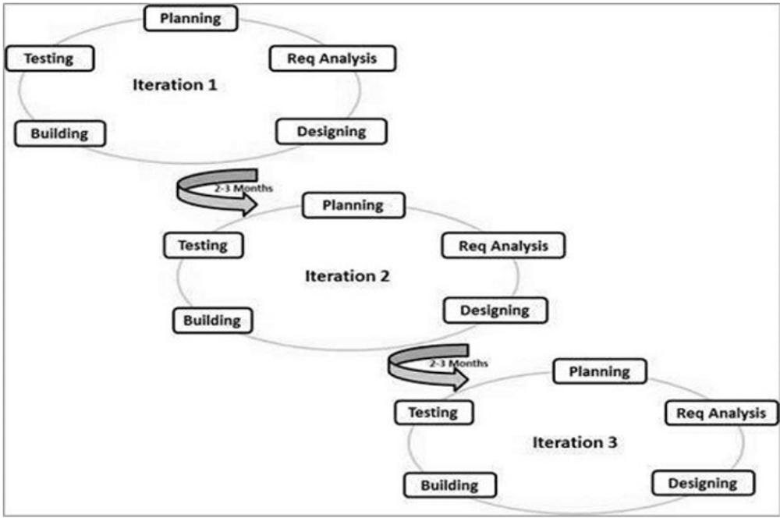

Agile Vs Traditional SDLC Models
Agile is based on the adaptive software development methods, whereas the traditional SDLC models like the waterfall model is based on a predictive approach. Predictive teams in the traditional SDLC models usually work with detailed planning and have a complete forecast of the exact tasks and features to be delivered in the next few months or during the product life cycle. Predictive methods entirely depend on the requirement analysis and planning done in the beginning of cycle. Any changes to be incorporated go through a strict change control management and prioritization. Agile uses an adaptive approach where there is no detailed planning and there is clarity on future tasks only in respect of what features need to be developed. There is feature driven development and the team adapts to the changing product requirements dynamically. The product is tested very frequently, through the release iterations, minimizing the risk of any major failures in future.
Customer Interaction is the backbone of this agile methodology, and open communication with minimum documentation are the typical features of agile development environment. The agile teams work in close collaboration with each other and are most often located in the same geographical location.
Advantages of agile model
The advantages of the Agile Model are as follows
• Is a very realistic approach to software development
• Promotes teamwork and cross training
• Functionality can be developed rapidly and demonstrated
• Resource requirement are minimum
• Suitable for fixed or changing requirement
• Delivers early partial working solutions
• Easy to manage
• Give flexibility to developers

4.2 Scrum
Scrum is an agile framework for managing knowledge work, with an emphasis on software development. It is designed for teams of three to nine members, who break their work into actions that can be completed within time boxed iterations, called "sprints", no longer than one month and most commonly two weeks, then track progress and re-plan in 15-minute stand-up meetings, called daily scrums.
Scrum is an iterative and incremental framework for managing product development. It defines "a flexible, holistic product development strategy where a development team works as a unit to reach a common goal", challenges assumptions of the "traditional, sequential approach to product development, and enables teams to self-organize by encouraging physical co-location or close online collaboration of all team members, as well as daily face-to-face communication among all team members and disciplines involved.
A key principle of Scrum is the dual recognition that customers will change their minds about what they want or need and that there will be unpredictable challenges-for which a predictive or planned approach is not suited. As such, Scrum adopts an evidence-based empirical approach accepting that the problem cannot be fully understood or defined up front, and instead focusing on how to maximize the team's ability to deliver quickly, to respond to emerging requirements, and to adapt to evolving technologies and changes in market conditions.
Many of the terms used in Scrum (e.g., scrum master) are typically written with leading capitals (e.g. Scrum Master) or as conjoint words written in camel case (e.g., Scrum Master). To maintain an encyclopaedic tone, however, this article uses normal sentence case for these terms-unless they are recognized marks. This is occasionally seen written in all -capitals, as SCRUM. The word is not an acronym, so this is not correct; however, it likely arose due to an early paper by Ken Schwaber which capitalized SCRUM in its title.
While the trademark on the term Scrum itself has been allowed to lapse, so that it is deemed as owned by the wider community rather than an individual, the leading capital is retained-except when used with other words.

SYSTEM REQUIREMENT SPECIFICATION

5. SYSTEM REQUIREMENTS SPECIFICATION

Placement coordination system has 3 actors and they have the following functionalities
• Placement coordinator
• View students, registered companies and approve or disapprove them
• Send notification to student and company
• Company
• Company registration
• View status (approved or disapproved)
• Add job vacancies own profile
• View filtered students
• View notification from placement coordinator
• Edit profile
• Student
• Registration
• Edit profile
• View notification from placement coordinator

5.1 Software Requirements
The incoming message mostly includes request for a specific task. The incoming message will be converted to a specific format in the database language, the processing made and request served. The operation will be intended to be made fast as possible. It is selected such a way that it reduces our work and easy to implement the project anywhere.
Software requirements for developer:
• Operating system : window 7 or above
• Frond end : python
• IDE : PyCharm
• Framework : Django
• Backend : MySQL
• Tools : HTML, CSS

5.2. Hardware Requirements

The hardware requirements explain the hardware components the need to develop our project. It is selected such a way that it reduces our work and easy to implement the project anywhere.
❖ Hardware requirements for developers
• Processor : 64-bit processor
• Ram : min 8gb
• Hard disk: 1 TB

SYSTEM DESIGN

6. SYSTEM DESIGN

System design is the first in the development phase for many engineered product or system. It may define the process of applying various techniques and principles for the purpose of defining a device, a process or system in sufficient detail to permit its physical realization. This phase is the first step in moving from the problem domain to the solution domain. It is an iterative process through which requirements are transmitted into “blue print” for constructing the software initially. Blue print depicts holistic new software. That is, design is represented at high level of abstraction, functional and behavioral requirements. System design is creative art of inverting and developing inputs, database and offline files, communication between the software clients and server, methods and procedure for processing data to get meaningful output that satisfy the organization objectives. From the project management view, software design is conducted in two steps. Preliminary design is concerned with the transformation of the requirements into data and architecture. Detailed design focuses on refinement to the architectural representation for software. Some properties for the system design are:
    - Verifiability

    - Completeness

    - Efficiency

    - Traceability

6.1 Input Design
The input design is the process of converting the user oriented into the computer based formats. So the design of the user interface is very important for any application. a good interface design lead to an interface software application. Input design consist of the development of specification, the necessary step to convert the given data into useable form for processing, data entry and activity of putting the data into computer for processing. all input processes have been designed with almost care to avoid the entry of the invalid data into the system

The input screens have been validated effectively in order to give the most, accurate input details. Some aspects have to be followed while designing the input screen.
- The data to input
- The details of how data should be arranged or coded
- Allow the information only the user needs
- Same styles among screens have to be kept
- Confirmation of critical details to be asked
- Validate data as soon as possible on inputs

The input design requirements such as user friendliness, consistent format and interactive dialogue for giving the right message and helps for the users at the right time are also necessary for the development of good software.
6.2Output design
Computer output is the most important and direct source of information to the user .it determines how the information is to be displayed for immediate need.it improves the system relationship with the user.
The output generally refers to the results and information that is generated form the system. Output necessary for the users to communicate with the result of processing .it also provides permanent hard copy for later consultation. They are obtained in the form if response to the request.
6.3 Database Design
Database design is the process of producing a detailed data model of a database. This logical data model contains all the needed logical and physical design choices and physical storage parameters needed to generate a design in a data definition language, which can then be used to create a database. The term database design can be used to describe many different parts of the design of an overall database system. Principally, and most correctly, it can be thought of as the logical design of the base data structures used to store the data.

In the relational model these are the tables and views. In an object database the entities and relationships map directly to object classes and named relationships. However, the term database design could also be used to apply to the overall process of designing, not just the base data structures, but also the forms and queries used as part of the overall database

application within the database management system. The process of doing database design generally consists of a number of steps which will be carried out by the database designer.
Usually, the designer must: Determine the relationships between the different data elements and superimpose a logical structure upon the data on the basis of these relationships.
Normalization
It is a process of converting a relation to a standard form. The process is used to handle the problems that can arise due to data redundancy i.e. repetition of data in the database, maintain data integrity as well as handling problems that can arise due to insertion, updation, deletion anomalies.
Decomposing is the process of splitting relations into multiple relations to eliminate anomalies and maintain anomalies and maintain data integrity. To do this we use normal forms or rules for structuring relation.
Insertion anomaly: Inability to add data to the database due to absence of other data.
Deletion anomaly: Unintended loss of data due to deletion of other data.
Update anomaly: Data inconsistency resulting from data redundancy and partial update
Normal Forms: These are the rules for structuring relations that eliminate anomalies.
- First Normal Form (1NF):
A relation is said to be in first normal form if the values in the relation are atomic for every attribute in the relation. By this we mean simply that no attribute value can be a set of values or, as it is sometimes expressed, a repeating group.

- Second Normal Form (2NF):
A relation is said to be in second Normal form is it is in first normal form and it should satisfy any one of the following rules.
- Primary key is a not a composite primary key
- No non key attributes are present
- Every non key attribute is fully functionally dependent on full set of primary key.

6.4 Tables
Table name: login
Primary key: id
Column name | Data type | Description
id | Int(11) | Primary key
username | varchar (20) | username
password | varchar (20) | password
logintype | varchar (20) | Type of login

Table name: stregistration
Primary key: stid
Column name | Data type | Description
stid | Int | Primary key
sfirstname | varchar (12) | First name of student
smiddlename | varchar (12) | Middle name of student
slastname | Varchar(12) | Last name of student
smail | varchar (35) | Mail id of student
snumber | bigint (20) | Phone number of student
sgender | varchar (20) | Gender of student
snationality | Varchar(20) | Nationality of student
smartial | Varchar(12) | If student Married or not
slanguage | Varchar(80) | Languages known by student
stimg | Varchar(80) | Name of Photo of student
studsign | Varchar(80) | Signature of student filename
squalification | Varchar(80) | Qualification of student
sskills | Varchar(80) | Skills attained by student
studexperience | Varchar(80) | Job experience of student
login_idd_id | Int(11) | Foreign key

Table name: cmpregistration
Primary key: cmid
Column name | Data type | Description
cmid | int(11) | Primary key
cname | varchar (30) | Name of company
caddress | varchar (60) | Address of company
ccity | varchar (20) | City company is placed in
cstate | varchar (20) | State company is placed in
ccmpno | varchar (20) | Phone number of company
cemail | varchar (30) | Email id of company
ccontactname | varchar (20) | Person of contact in company
ctitle | varchar (20) | Title of the contact person
login_id_id | int(11) | Foreign key

Table name: cmvaccancy
Primary key: cmid
Column name | Data type | Description
cmid | Int | Primary key
cmtitle | varchar(20) | Job title
cmlocation | varchar (25) | Location of work
cmjobtype | varchar (20) | Type of job
cmsalary | Int (11) | Salary offered
cmworkinghrs | varchar(10) | Working hours of job
cmqualification | varchar(60) | Qualification required
cmbranch | varchar(300) | Branch’s needed
cmperccentage | varchar(20) | Percentage of marks required
cmyearofpass | varchar(25) | Year the student have graduated
cmbacklogs | varchar(25) | No of max backlogs
cmage | varchar(25) | Age of students required
cmgender | varchar(7) | Gender of student
cmmartial | varchar(10) | Martial status of student
cmexperience | varchar(20) | Job experience the student have
cmlanguage1 | varchar(60) | A preferred language
cmlanguage2 | varchar(60) | Secondary preferred language
cmreqdocs | varchar(100) | Documents the student should have
cmdate | varchar(30) | Date of conducting the event
cmtime | varchar(10) | Time of conducting event
cmv_idd_id | int(11) | Foreign key

Table name: education
Primay key: eid
Column name | Data type | Description
eid | Int (11) | Primary key
course | varchar(50) | Course taken by student
branch | varchar (50) | The branch of course the student belongs to
yearofpass | varchar (40) | Year student has graduated
backlog | varchar (40) | Number of backlogs student has
percentage | varchar (40) | The percentage of final marks
sid_id | Int (11) | Foreign key

Table name: notification
Primay key: adid
Column name | Data type | Description
adid | Int (11) | Primary key
adnotification | varchar(20) | The message to be passed
sendto | varchar (20) | The intended user type to send to
date | varchar (20) | Date the message was send

Table name: filtered
Primay key: fid
Column name | Data type | Description
fid | Int (11) | Primary key
cmidd_id | Int (11) | Foreign key
stidd_id | Int (11) | Foreign key

6.4 UML Designs

The unified Modelling Language (UML) is a standard language for specifying, visualizing, constructing, and documenting the artefacts of the software systems, as well as for business modelling and other non-software systems. The UML represents a collection of best engineering practices that have proven successful in the modelling of large and complex systems. The UML is a very important part of developing objects-oriented software and software development process. The UML uses mostly graphical notations to express the design of software projects. Using the UML helps project teams communicate, explore potential designs, and validate the architectural design of the software.

Goals of UML

The primary goals in the design of the UML are:

    - Provide users with a ready-to-use, expressive visual modelling language so they can develop and exchange meaningful models.

    - Provide extensibility and specialization mechanisms to extend the core concepts.

    - Be independent of particular programming languages and development processes.

    - Provide a formal basis for understanding the modelling language.

    - Encourage the growth of the OO tools market.

    - Support higher-level development concepts such as collaborations frameworks, patterns and components.

    - Integrate bets practice.

As the strategic value of the software increase for many companies, the industry looks for techniques to automate the production of software and to improve quality and reduce cost and
time to market. These techniques include component technology. Visual programming, patterns and frameworks. Businesses also seek techniques to manage the complexity of systems as they increase in the scale. In particular, they recognize the need to solve recurring problems such as physical distribution, concurrency, replication, security, load balancing and fault tolerance.
Additionally, the development for the World Wide Web, while making something simpler, has extracted these architectural problems

Use Case diagram A use case describes how a user uses a system to accomplish a particular goal. A use case diagram consists of the system, the related use cases and actors and relates these to each other to visualize. Use cases help ensure that the correct system is developed by capturing the requirements from the user's point of view.
Class Diagram Models class structure and contents using design elements such as classes, packages and objects. It also displays relationships such as containment, inheritance, associations and others.

Interaction Diagrams
- Sequence Diagram displays the time sequence of the objects participating in the interaction. This consists of the vertical dimension (time) and horizontal dimension (different objects).

- Collaboration Diagram displays an interaction organized around the objects and their links to one another. Numbers are used to show the sequence of messages.

- State Diagram displays the sequences of states that an object of an interaction goes through during its life in response to received stimuli, together with its responses and actions.

- Activity Diagram displays a special state diagram where most of the states are action states and most of the transitions are triggered by completion of the actions in the source states. This diagram focuses on flows driven by internal processing. Physical Diagrams

- Component Diagram displays the high-level packaged structure of the code itself. Dependencies among components are shown, including source code components, binary code components, and executable components. Some components exist at compile time, at link time, at run times well as at more than one time.

- Deployment Diagram displays the configuration of run-time processing elements and the software components, processes, and objects that live on them. Software component Instances represent run-time manifestations of code units.

Physical Diagrams
- Component Diagram displays the high-level packaged structure of the code itself. Dependencies among components are shown, including source code components, binary code components, and executable components. Some components exist at compile time, at link time, at run times well as at more than one time.
- Deployment Diagram displays the configuration of run-time processing elements and the software components, processes, and objects that live on them. Software component Instances represent run-time manifestations of code units.

6.5 Sequence Diagram

A sequence diagram is an interaction diagram that shows how the processes operate with one another and what order. It is a construct of a message sequence chart. Sequence diagram shows message interactions arranged in same sequence. It depicts the object and classes involved in the scenario and the sequence of messages exchanged between the objects needed to carry out the functionality of the scenario. Sequence diagrams are typically associated with use case realization in logical view of the system under development. Sequence diagram re sometimes called event diagrams or event scenarios.
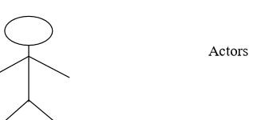

An object: A class
have different processes or objects that live simultaneously

Horizontal arrows that show the message exchanged between them, in the order in which they occur

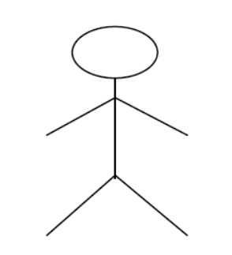 Focus of control is an execution occurrence shown as
rectangle on a lifeline that represents the period during
which an element is performing an operation. The top
and the bottom of the rectangle is aligned with the
initiation and the completion time respectively.

6.6 Use case diagram
PLACEMENT COORDINATION SYSTEM

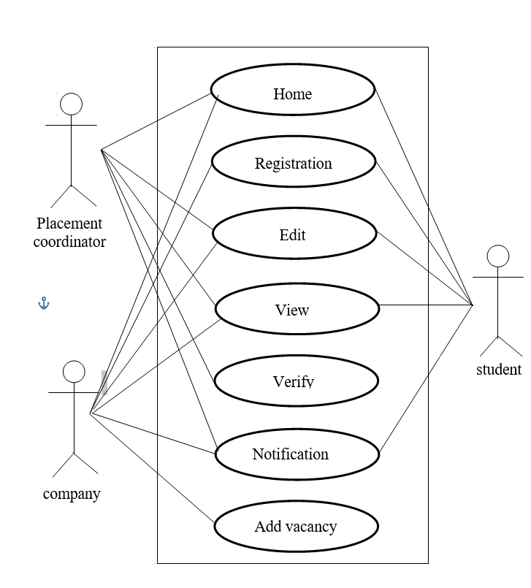

6.7 Scenario
1.placement coordinator
• View registered companies and verify
• Send notification to student and company
2.company
• Registration
• View status
• Add vacancies
• View filtered students
• View notification from placement
• Edit profile
3.student
• Registration
• Edit
• View notification

6.8 Sequence Diagram

REGISTRATION

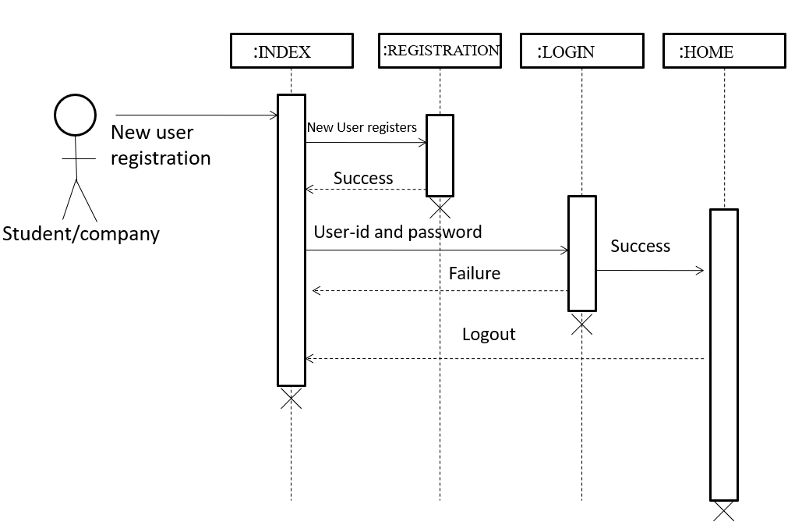

PLACEMENT COORDINATOR

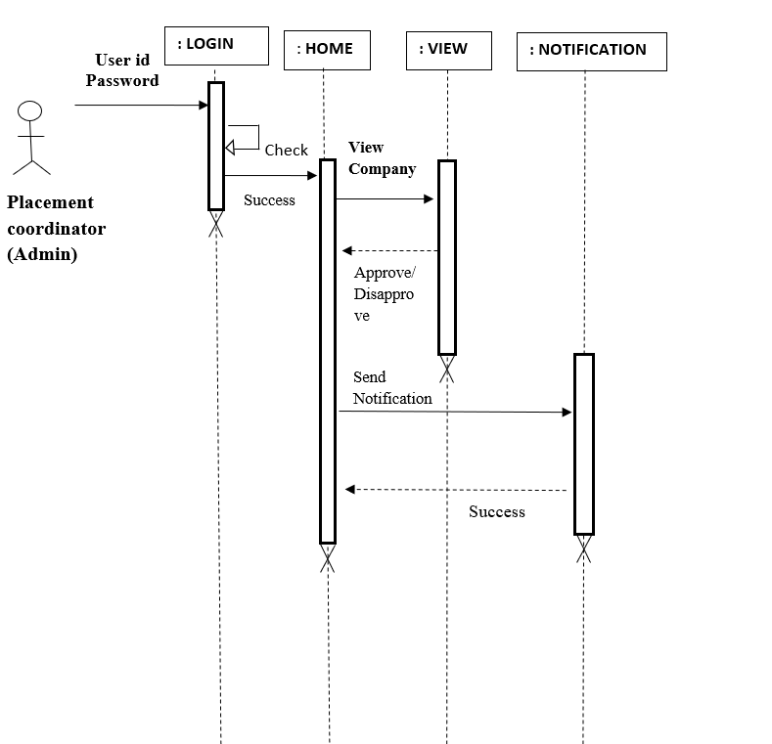

STUDENT

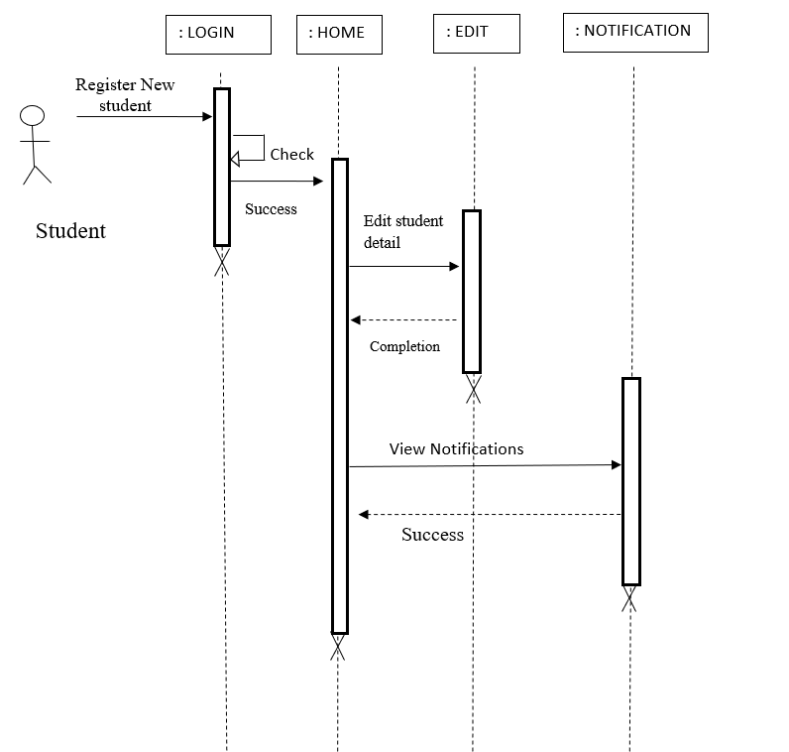

COMPANY

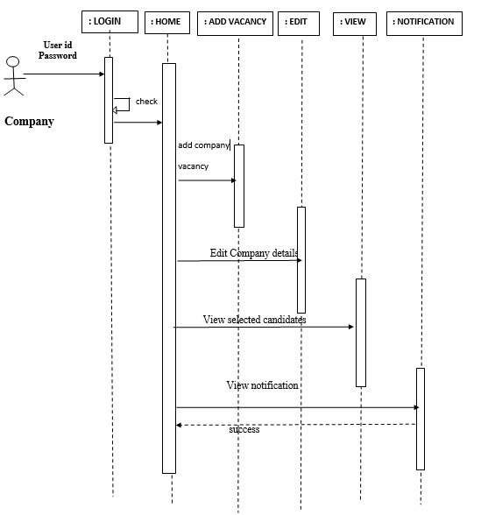

CLASS DIAGRAM

PLACEMENT COORDINATOR

NOTIFICATION

COMPANY
STUDENT

VACCANCY

FILTERATION

REPORT

SYSTEM DEVELOPMENT

7. SYSTEM DEVELOPMENT
System development is series of operations to manipulate data to produce output from computer system. The principle activities performed during the development phase can be divided into two major related sequences.

    - External system development

    - Internal system development

The major external system activities are:

- Implementation

    - Planning

    - Equipment acquisition

    - Installation

7.1 Coding

The purpose of code is to facilitate the identification and retrieval of items of information. A code is an ordered collection of symbols designed to provide unique identification of entity or an attribute. Code also show interrelationship among different items. Codes are used to identify, access, sort, matching records. The code ensures that only one value of code with a single meaning is applied to give entity or attribute as described in various ways.

Python – An Overview

Python is a widely used high-level programming language for general-purpose programming, created by Guido van Rossum and first released in 1991. An interpreted language, Python has a design philosophy that emphasizes code readability (notably using whitespace indentation to delimit code blocks rather than curly brackets or keywords), and a syntax that allows programmers to express concepts in fewer lines of code than might be used in

languages such as C++ or Java. The language provides constructs intended to enable writing clear programs on both a small and large scale. Python features a dynamic type system and automatic memory management and supports multiple programming paradigms, including object- oriented, imperative, functional programming, and procedural styles. It has a large and comprehensive standard library. Python interpreters are available for many operating systems, allowing Python code to run on a wide variety of systems. C Python, the reference implementation of Python, is open source software and has a community-based development model, as do nearly all of its variant implementations. C Python is managed by the non-profit Python Software Foundation. Python is a multi-paradigm programming language: object-oriented programming and structured programming are fully supported, and many language features support functional programming and aspect-oriented programming (including by meta-programming and meta-objects (magic methods)). Many other paradigms are supported via extensions, including design by contract and logic programming. Python uses dynamic typing and a mix of reference counting and a cycle-detecting garbage collector for memory management. An important feature of Python is dynamic name resolution (late binding), which binds method and variable names during program execution. The design of Python offers some support for functional programming in the Lisp tradition. The language has filter (), map (), and reduce () functions; list comprehensions, dictionaries, and sets; and generator expressions. The standard library has two modules (itertools and functools) that implement functional tools borrowed from Haskell and Standard ML.
Git
Git is a type of version control system (VCS) that makes it easier to track changes to files. For example, when you edit a file, git can help you determine exactly what changed, who changed it, and why. It’s useful for coordinating work among multiple people on a project, and for tracking progress over time by saving “checkpoints”. You could use it while writing an essay, or to track changes to artwork and design files. Git isn’t the only version control system out there, but it’s by far the most popular. Many software developers use git daily, and understanding how to use it can give a major boost to your resume. In a classical source code repository, folder with files and subfolders are handled as content. The repository holds all versions of the content, while the working directory is the place where you modify the code. You checkout code from the repository to the working directory and commit changes you have made in this working directory back into a new version of the content in the repository.

MYSQL Database
Microsoft SQL Server is a relational database management system developed by Microsoft. As a database server, it is a software product with the primary function of storing and retrieving data as requested by other software applications-which may run either on the same computer or on another computer across a network (including the Internet).Microsoft markets at least a dozen different editions of Microsoft SQL Server, aimed at different audiences and for workloads ranging from small single-machine applications to large Internet-facing applications with many concurrent users. Structured Query Language is a domain-specific language used in programming and designed for managing data held in a relational database management system (RDBMS), or for stream processing in a relational data stream management system (RDSMS).

Originally based upon relational algebra and tuple relational calculus, SQL consists of a data definition language, data manipulation language, and data control language. The scope of SQL includes data insert, query, update and delete, schema creation and modification, and data access control. Although SQL is often described as, and to a great extent is, a declarative language (4GL), it also includes procedural elements. SQL was one of the first commercial languages for Edgar F. Codd'srelational model, as described in his influential 1970 paper, "A Relational Model of Data for Large Shared Data Banks". Despite not entirely adhering to the relational model as described by Codd, it became the most widely used database language. SQL became a standard of the American National Standards Institute (ANSI) in 1986, and of the International Organization for Standardization (ISO) in 1987. Since then, the standard has been revised to include a larger set of features. Despite the existence of such standards, most SQL code is not completely portable among different database systems without adjustments.

SYSTEM TESTING AND
IMPLEMENTATION

8. SYSTEM TESTING AND IMPLEMENTATION
Testing is the vital to the success of the system. It makes a logical assumption that if all the parts of the system are correct, the goal will be successfully achieved inthis project. It is the stage of implementation, which ensures that system works accurately and effectively before the live operation commences. It is a confirmation that all are correct and opportunity to show users that the system must be tested and show that the system will operate successfully and produce expected results under expected conditions. Software testing is a crucial element of software quality assurance and represents the unlimited review of specification, design and coding. Testing represents an interesting anomaly for the software. During the earlier definition and development phase, it was attempted to build the software from an abstract concept to implement.
Testing is a set of activity that can be planned in advance and conducted. Systematically, this is aimed at ensuring that the system works accurately and efficiently before live operations commences.
8.1 Types of Testing:

Different types of testing are,
• Unit testing
• Integration testing
• System testing
• Validation testing
• User acceptance testing.

Unit Testing
Unit testing is usually conducted as part of a combined code and unit test phase of the software lifecycle, although it is not uncommon for coding and unit testing to be conducted as two distinct phases. All modules were tested and individually as soon as they were completed and were checked for their correct functionality. Unit testing deals with testing a unit as a whole. This would test the interaction of many functions but confine the test within one unit. This testing is carried out during programming stage itself. In this testing step each Module is found to be working satisfactorily as regard to the expected output from the module.

Integration Testing
Integration testing is a systematic technique for testing to overcome the errors associated within the interface. In this System all the modules such as login, registration, admin in web, user in web, and the final hardware and software are combined and then the entire program is tested as a whole. Thus in the integration testing step all the errors in the implementation of the system are corrected. Data can be lost across an interface one module can have an adverse effect on others; sub-functions when combined may not produce the desired major functions integration testing is a systematic testing for constructing the program structure. The objective is to take unit tested modules and to combine them and test it as a whole.
• The system contains various components and they have to be combined and tested.
• The software is embedded into hardware and tested.
• The modules are combined and tested.
• The hardware part tested separately.
System Testing
After performing the validation testing, the next step is output testing of the proposed system since no system could be useful if it doesn’t produce the required data in the specific format. The output displayed or generated by the system under consideration is tested by, asking the user about the format displayed. The output format on the screen is found to be correct as the format was designed in the system phase according to the user needs. Hence the output testing doesn’t result in any correction in the system.
User Acceptance Testing:
User Acceptance of the system is the key factor for the success of the system. The system under consideration is tested for user Acceptance by constantly keeping in touch with prospective system at the time of developing and making change wherever required. This is done with regard to the following points.
• Output Screen design.
• Input Screen design.
• Menu driven system.

8.2 Implementation
Implementation is the stage of project, when theoretical design is turned in to a working system. The most crucial stage is achieving a successful system and confidence that the new system will be work effectively. It involves careful planning, investigation of the manual system and to new system.
Implementation means converting a new or revised system design into an operational one. The implementation includes all those activities that take place to convert from the old system to the new one
There are several activities involved while implementing a project:
• Careful planning.
• Investigating the current system and its constraints on implementation.
• Design of methods to achieve the changeover.
• Training of the staff in the changeover procedure and evaluation of change over method.
Implementation is the final stage and it is an importance phase. The first task in implementation was the implementation planning, that is deciding on methods to be adopted. After the system was implemented successfully, training of the user was one of the most important subtasks of the developer. For this purpose the user or system manual were prepared and handled over to the user to operate the developed system. So change over plays a vital role, which checks the developed tool for the following requirements, and then only the user accepted the developed tool. The changeover took place only when the system had been proved to the satisfaction of the system analysis and other implementation activities have been completed.

SYSTEM MAINTENANCE

9. SYSTEM MAINTENANCE
Maintenance is making adaptation of the software for external changes (requirements changes or enhancements) and internal changes (fixing bugs). When changes are made during the maintenance phase all preceding steps of the model must be revisited.
There are three types of maintenance:
• Corrective (Fixing bugs/errors)
• Adaptive (Updates due to environment changes)
• Perfective (Enhancements, requirements changes.
Maintenance is enigma of the system development. The definition of the software maintenance can be given describing four activities that are undertaken after the program is released for use.
The maintenance activity occurs since it is unreasonable to assume that software testing will uncover all in a large system. The second activity that contributes the definition of maintenance occurs since rapid changes are encountered in every aspects of computing. The third activity involves recommendation for new capabilities, modification to the existing functions and general enhancements when the software is used. The fourth maintenance activity occurs when software is changed to improve future maintainability or reliability.

FUTURE ENHANCEMENT

10. FUTURE ENHANCEMENT
The project has a very vast scope in future. In future the same system could be tried to be implemented in more colleges. From being a simple web-based application to a mobile application would increase its potential use as well as ease of operation. We could further enhance the system by adding more functionalities like assigning dates for company and students, adding student attendance on events for company reviewing, selection notification for students and admin functionalities such as allotting a room in college for a dated event. So as we see the potential for growth is quite large and more functionalities can be added. Here in this project we are only covering a minor portion of the entire placement process, we can introduce more core functionalities such as companies posting selection results, company able to add image and files that could advertise themselves and add more details about them, students getting preparation details like syllabus to study or skills to acquire etc that could help them in the future events and getting constant updation about new opportunities in the industries. We could also have a scope of altering the entire system from its current state to social networking standards where students and companies could interact continuously in online forms or chat groups etc. Our goal in this project is to start a initial point towards automating the entire campus placement process and upon its success we could further continue to brainstorm more creative and interactive ways to simplify the process further. Given the time and effort the placement coordination system is a system which can alter the future of campus placement process entirely

CONCLUSION

11. CONCLUSION

By using this system, we are focusing on minimising the effort taken by a placement officer and placement staff while making it relative easy for students and companies to link with each other for placement and interview matters. Our proposed system will have the major benefit of linking the students with the right qualification and specifics that a company requires. This system is a web based application making it very easy to access and work with. By using our system we aim to create more students to participate in the program as well as encourage companies to host placement events. Taken in account the human resources, time and paperwork required to conduct a registration for placement programs our system simplifies the process by automating things to an extend..

